30 Day Servo Project - PLC (here)

Create a new program, here we are using a Controllogix 1756-A7 seven slot rack with the processor in slot 1 and firmware rev. 34. We will use state logic with state transition. Create the task structure

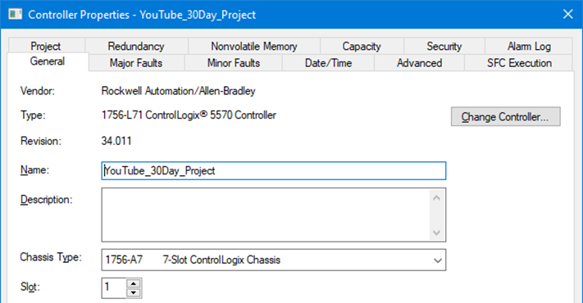
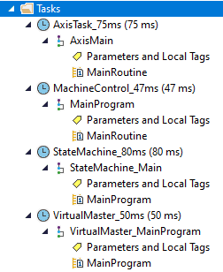

shown above at right confirming all the settings shown below, key items are circled in first group.

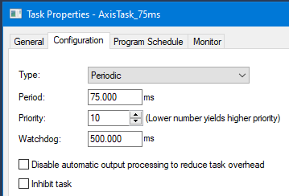
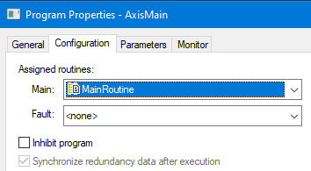

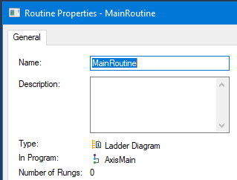
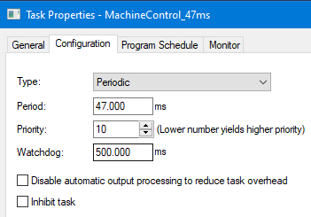

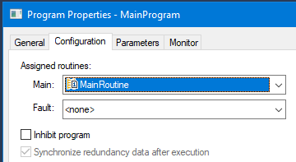
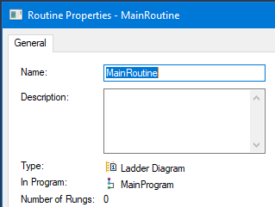
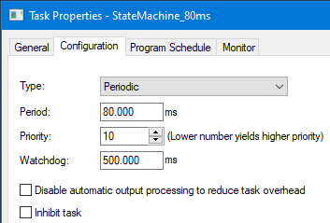
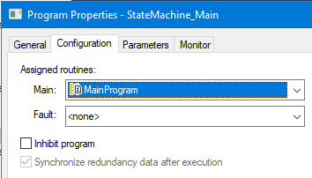

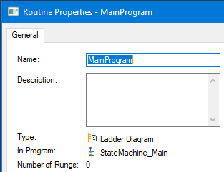
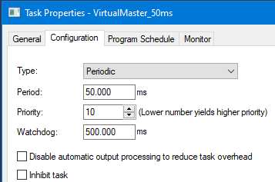

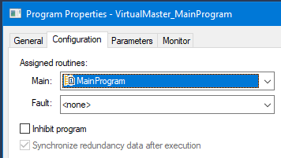
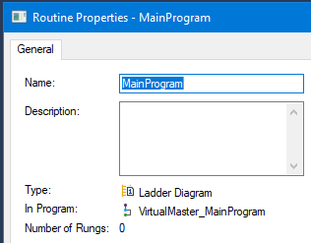
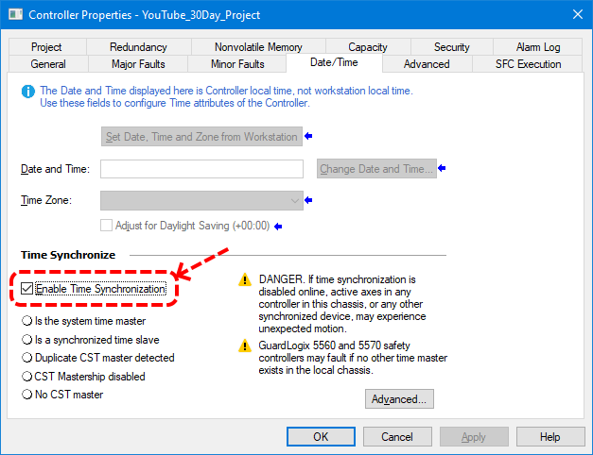

It is critically important to enable time synchronization in the controller properties as shown above.

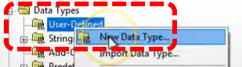

Now we will set up our UDT in the PLC application.

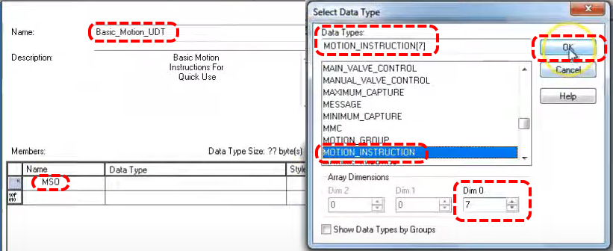

We have given our UDT the name Basic_Motion_UDT. We are adding the first member, it is the MSO motion instruction Motion Servo On. We think our application will have 5 axis so we select aa array dimension of 7 so we have spares. We have to select Data Type MOTION_INSTRUCTION.

Add the motion commands shown below.

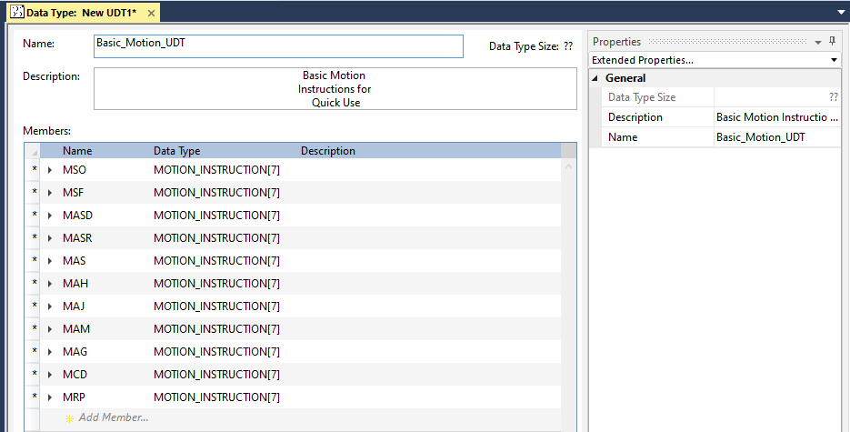

In this activity we will make all virtual axis since we are running on an emulator.

Create the below motion group then add the virtual axis.

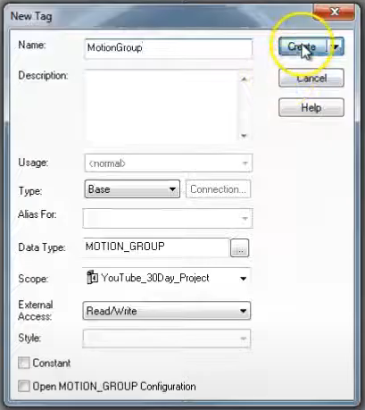
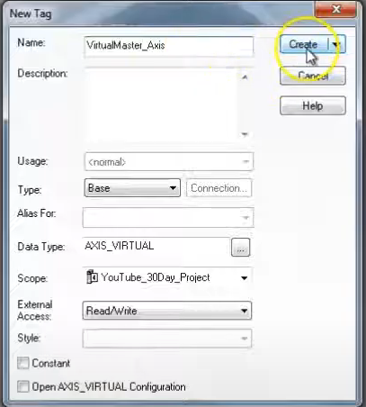
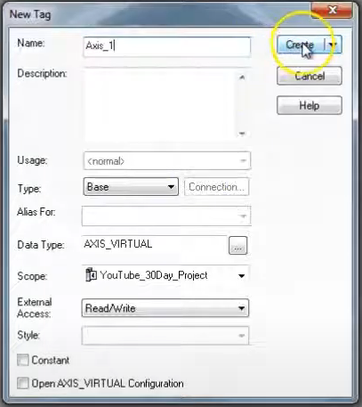
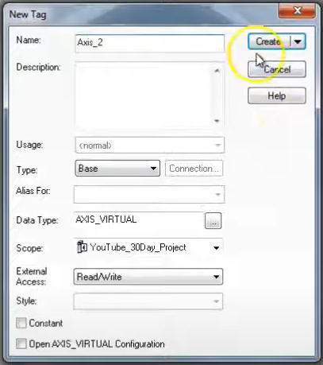

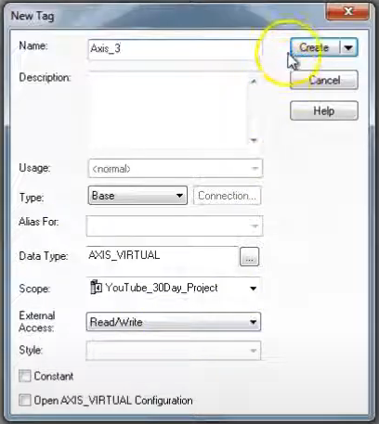
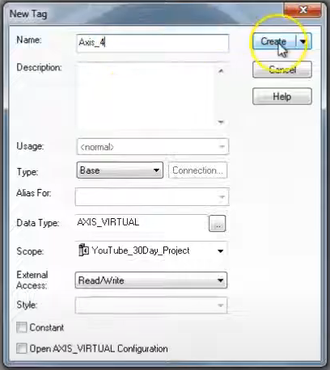

Open VirtualMaster_Axis, on the Conversion tab leave Position Mode at Linear and 8000. Homing should be Active and 0. Dynamics tab per below, use Calculate button, 25,000 for last two.

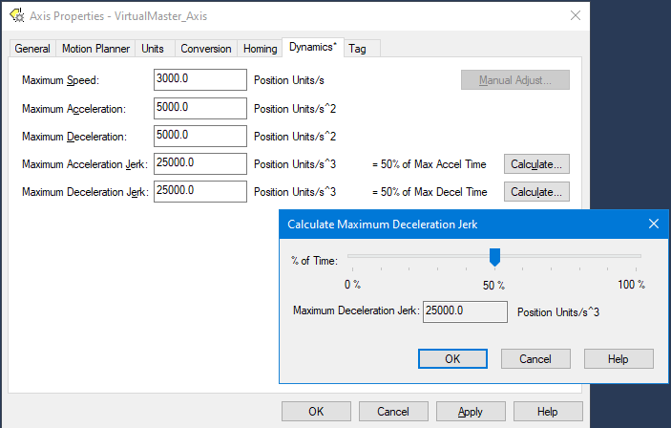

USE THESE SAME SETTINGS FOR ALL AXIS!
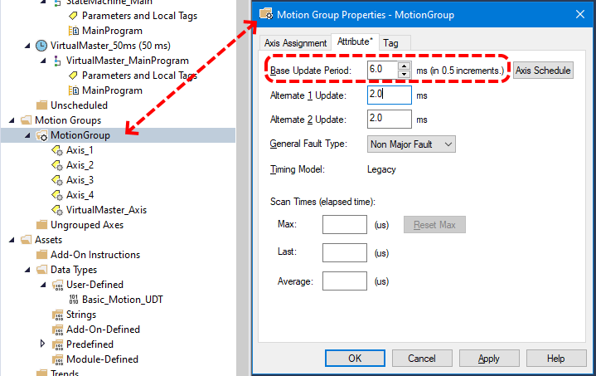

Under the Attribute tab of our motion group properties we want to set the Base Update Rate. We will allocate 1 ms for each axis (real or virtual) and another 1 ms for each configured drive in the IO Configuration section. Here we are using 6 ms to give our application a little slack. This number represents the periodic rate you are receiving information from your servos. In terms of processor allocation motion comes before IO and logic. For this reason we want as low as possible a base update rate. If your firmware version has Auto Tag Update it should be enabled. Set General Fault Type to your preference. Course Rate Update (aka Base Update Period) makes use of Enable Time Synchronization being enabled in the controller properties. In our case we have all axis assigned.

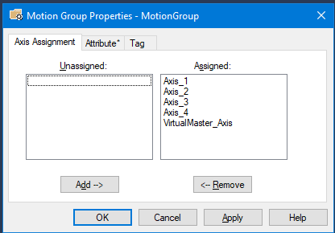

Now we are going to add routines for each axis, we will add routines and change the name of the original to better indicate. Note that each program added gets set to

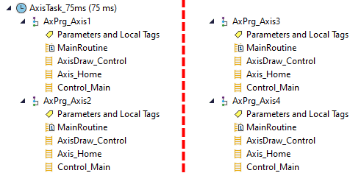

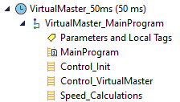

Now we will add other routines to the VirtualMaster_MainProgram group.

Now, in the MainProgram routine of VirtualMaster_MainProgram, add the JSR ladder for each sub.

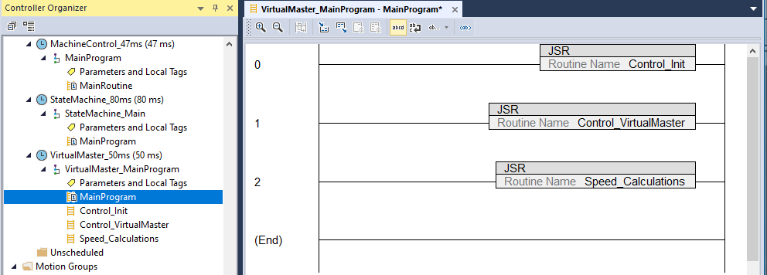

Add similar code for the AxPrg_Axis# routines.

Add four new routines to the StateMachine_80ms task; MachineState_Control (ld), Machine_SSL (st), Next_State (st, for HMI), Previous_State (st, for HMI). Add JSR code in Main.

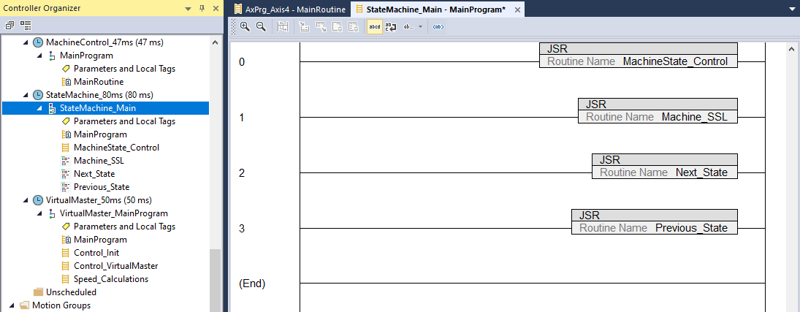

Now we will add our state tag database.

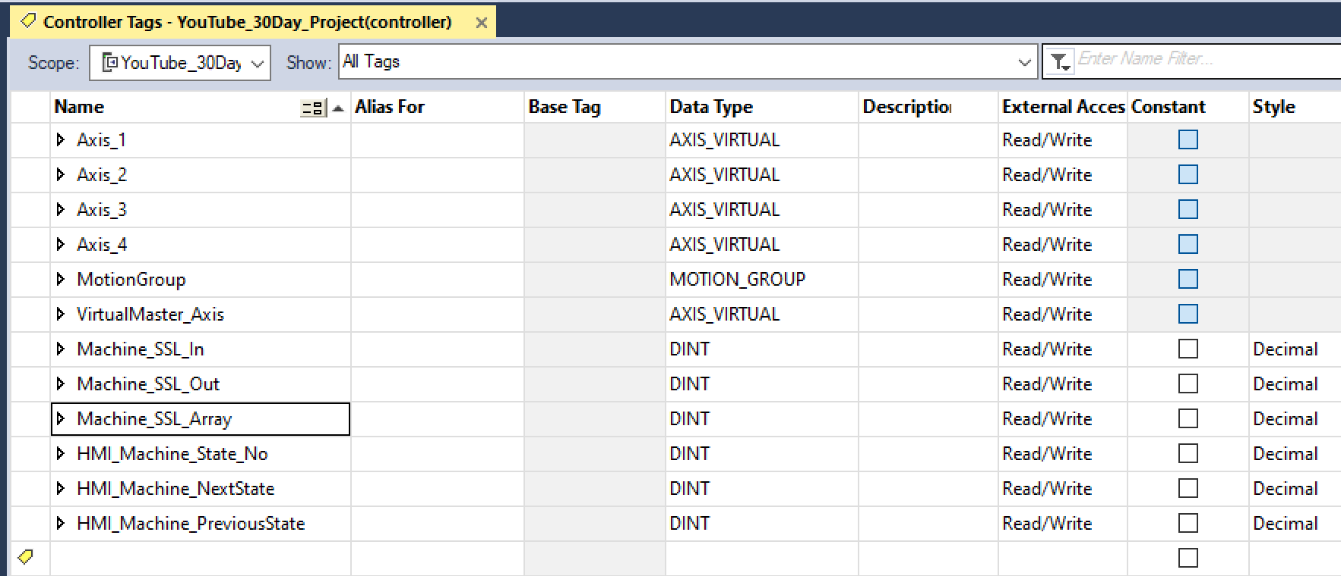

Now we add the structured text for Next_State in StateMachine. Take it up to case 31 which loops back to zero. Each case directs back to the previous case, case 0 stays at 0.

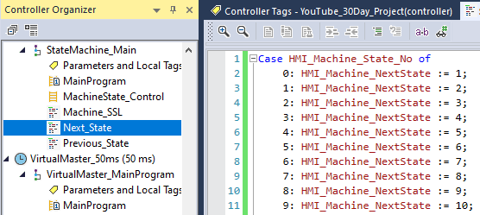
Now do the same (with modifications) for Previous_State.

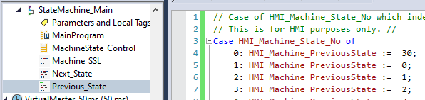

Now we will work on axis routines. In this application all drives will be following the virtual drive. Begin by adding fault monitoring code in AxPrg_Axis1:Control_Main.

First we want to check for faults in axis 1, we will access it’s collection of parameters and associate Axis_1.AxisFault with a new local parameter called AxisFault. Note that a value other than 0 indicates a fault. If this is the case we will set a fault solenoid.

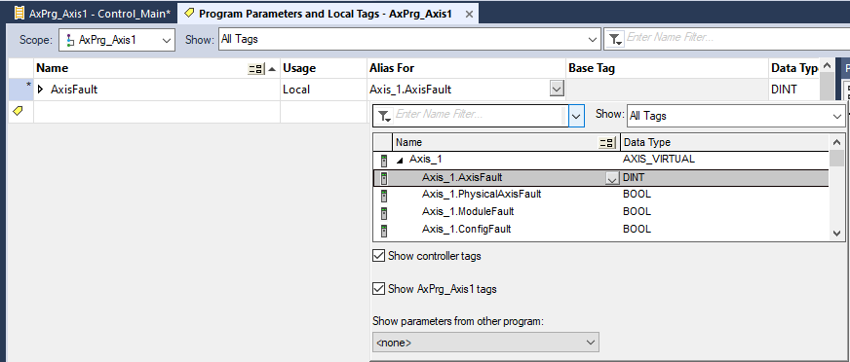

Next we examine a series of other fault parameters all associated with Axis_1. If none are in fault we set a local parameter Axis1_OkStatusBit. Note that we associate (alias) the axis tags with local vars.

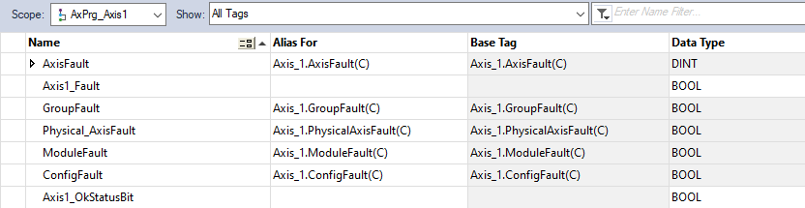

Next we process an HMI request for axis 1 reset. We will use the functions Motion Axis Shutdown Reset or Motion Axis Fault Reset depending on the state of tag Axis_1.ShutdownStatus (is the axis currently shutdown or not).

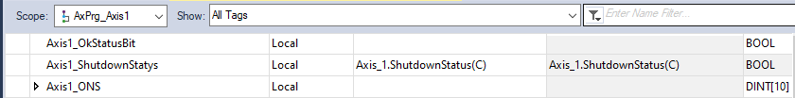

Now we want to access the motion command arrays we created in a UDT. We declare a local variable Axis1_ServoControls and give it data type of Basic_Motion_UDT as shown below.

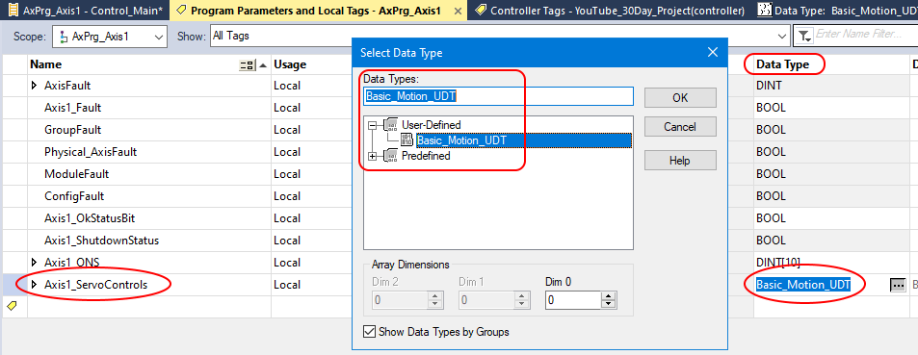

Now we have to add the motion command MAFR to our UDT.

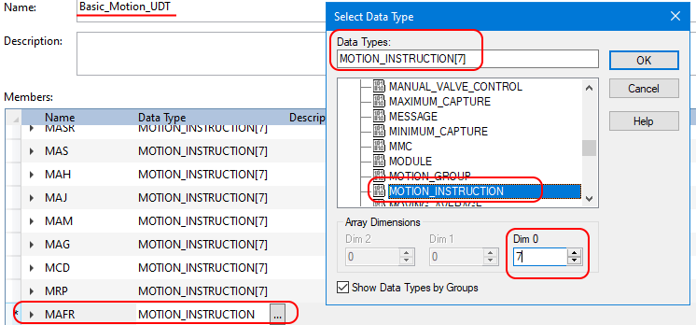

Completed fault status check below. The reason we have created these tags at the local level (and used aliases) is we want to be able to copy/paste into other modules and use recipe features. It is very quick to import/export and modify alias tag names. FW levels in the 30s have other methods.
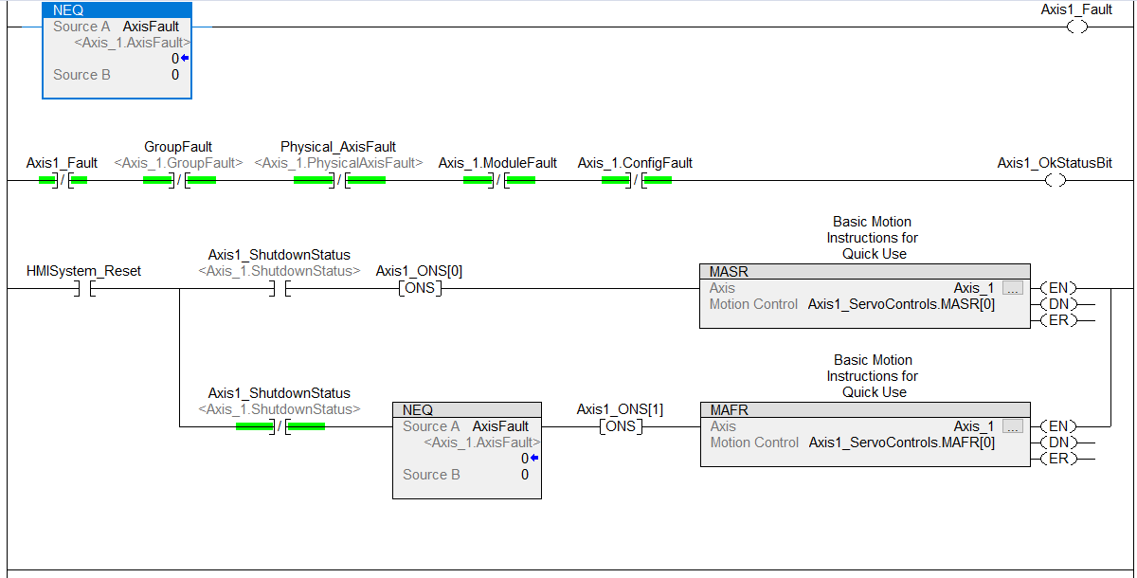
An actual servo system will have a more in depth status and fault checking scheme.

Note the above code does have two global tags; Axis1_OkStatusBit and HMISystem_Reset.

Now we want to export this routine from AxPrg_Axis1 and import it into AxPrg_Axis2. To export right click on the routine Control_Main. Next right click AxPrg_Axis2 and select Import.

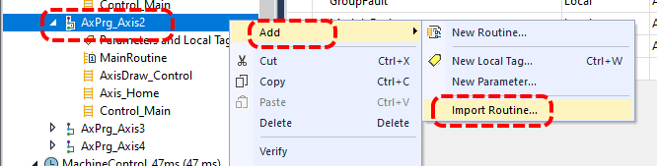

When window opens go to tags on the left hand pane. Everything in the Final Name column that says Axis1 we want to change to Axis2 (same goes for Axis_1 and Axis_2). Use the find & replace button. Check when done then click OK.

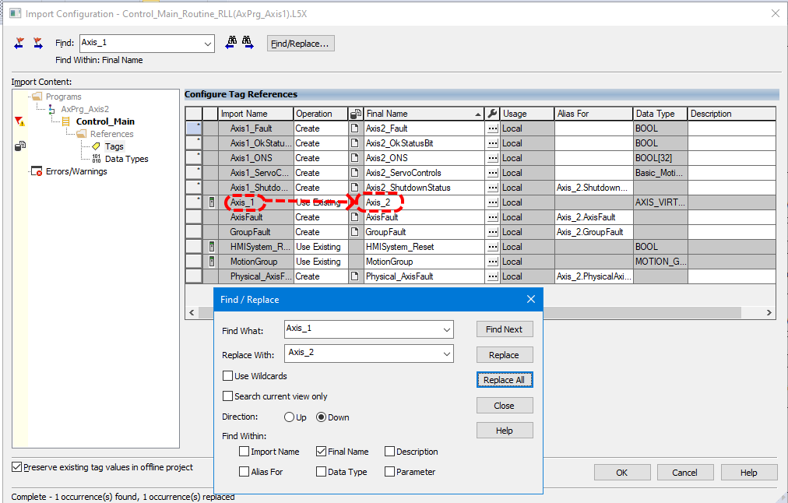

The code has been added to AxPrg_Axis2 with the parameter names changed.

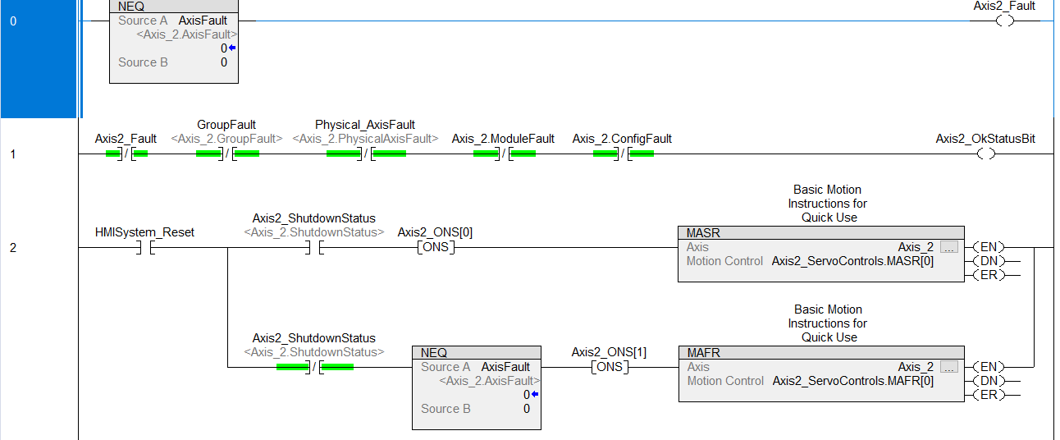

Repeat for axis 3 and 4.

Next we work on the Home code. Note that virtual axis turn themselves on when you home them, actual servos have a command to turn them on. We check the axis parameter .ServoActionStatus because if the axis is on it has already been homed and we do not want to home it again. Axis1_HomeStatus is controller scope and meant to be a kind of rool-up or indicator that the axis is being homed.

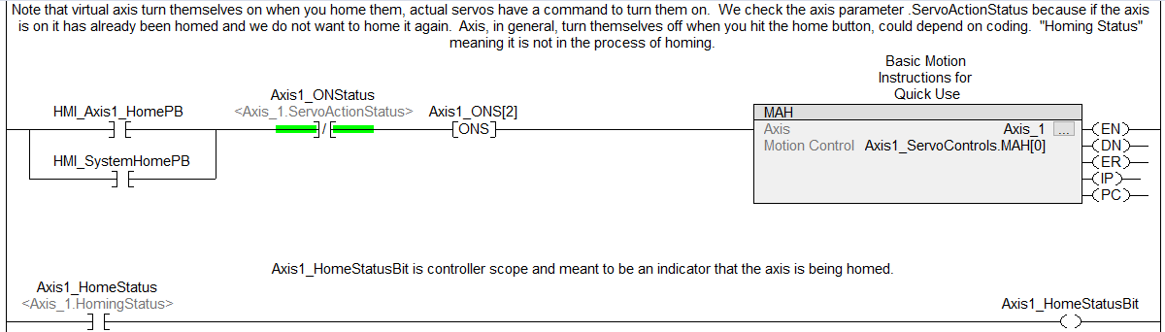

Now export the homing routine and import it into the other modules. Better to delete the existing Axis_Home module and import, then change the names. Writing over causes some parameter mix ups.

Moving on to coding the Draw_Control now. We will be gearing axis, the ratio of the gearing is actually the draw control. Anytime draw control changes the MAG command will recalculate the gearing. Method is: if an input to the draw control is not equal to the last value then we set a bool called Axis1_UpdateDraw which, on the next cycle, will enable the MAG block to recalculate the ratio. If an error is generated by the MAG [MAG[#].ER] command a fault is declared.

Begin by adding the below code to MachineControl_47ms|MainProgram.MainRoutine. Both parameters are controller scope.

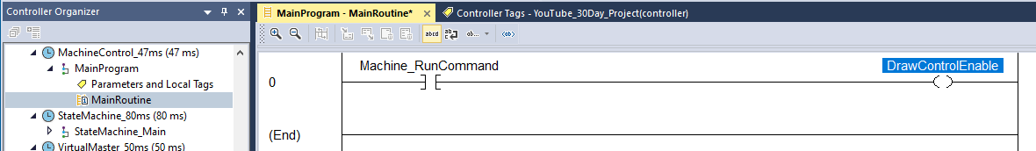
This block is kind of the start stop.

Now we will program the master jog into VirtualMaster_50ms - VirtualMaster_MainProgram - Control_VirtualMaster.

Setting Machine_RunCommand will set DrawControlEnable in MachineControl_47ms - MainProgram - MainRoutine.

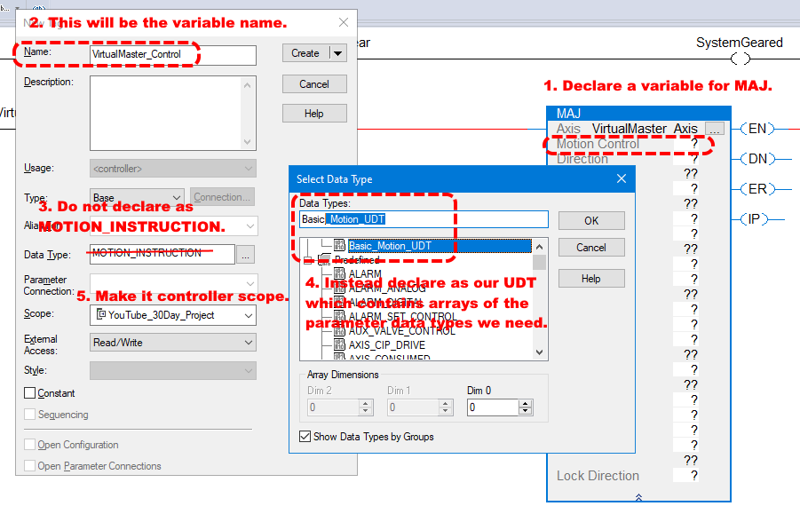
Above are the first steps in declaring our MAJ function.

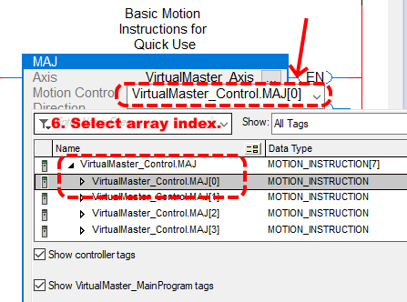

After we OK the above dialog we can come back in and select the array index we wish to use.

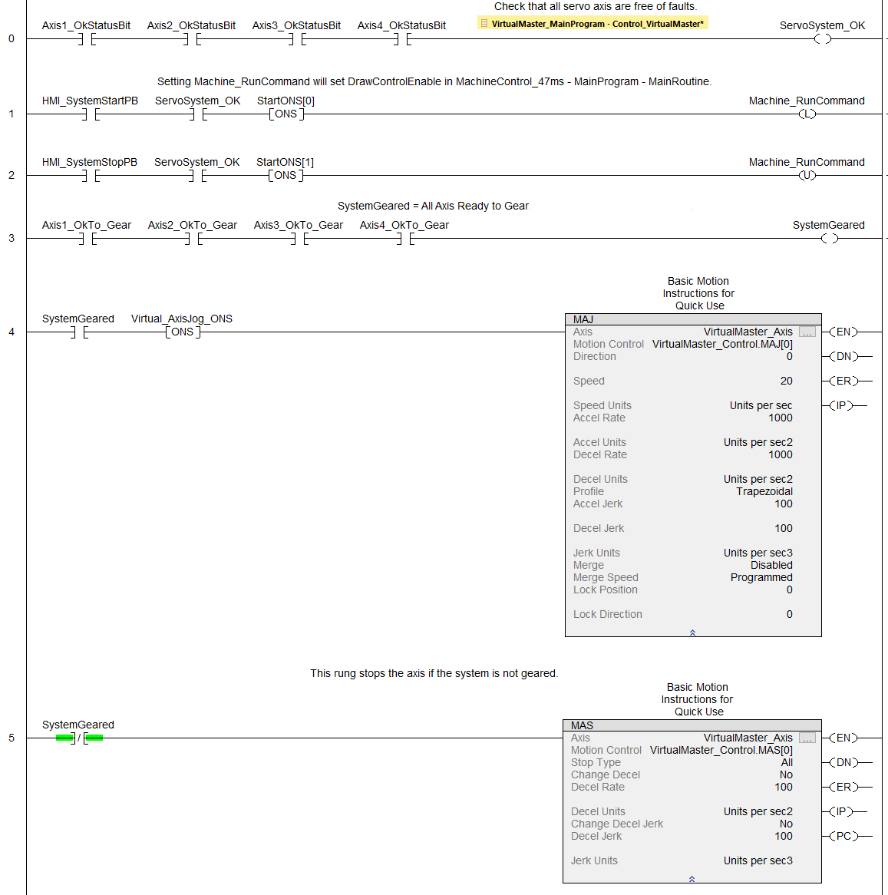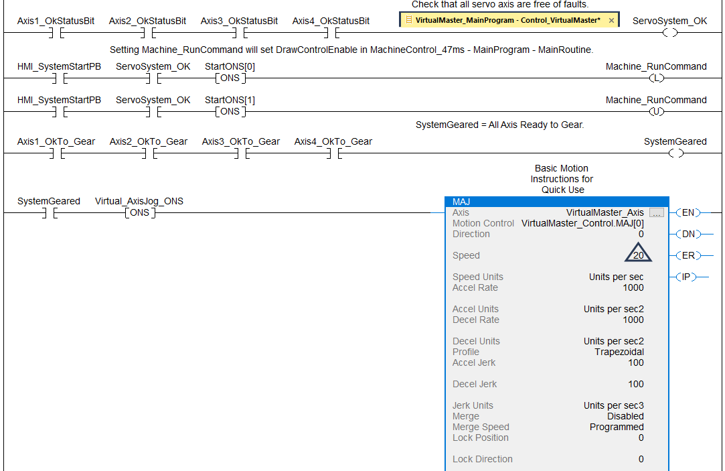
If running on an emulator now you can download and test run.

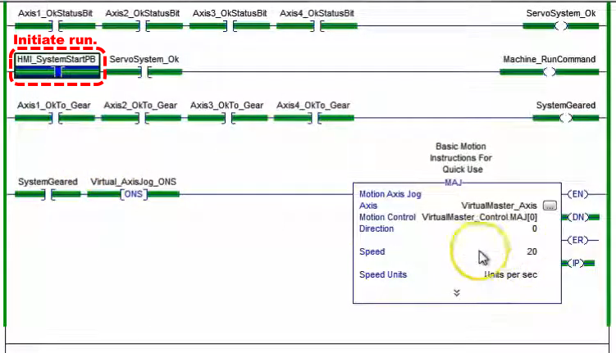
We can check the AxisDraw_Control code to see the axis running.
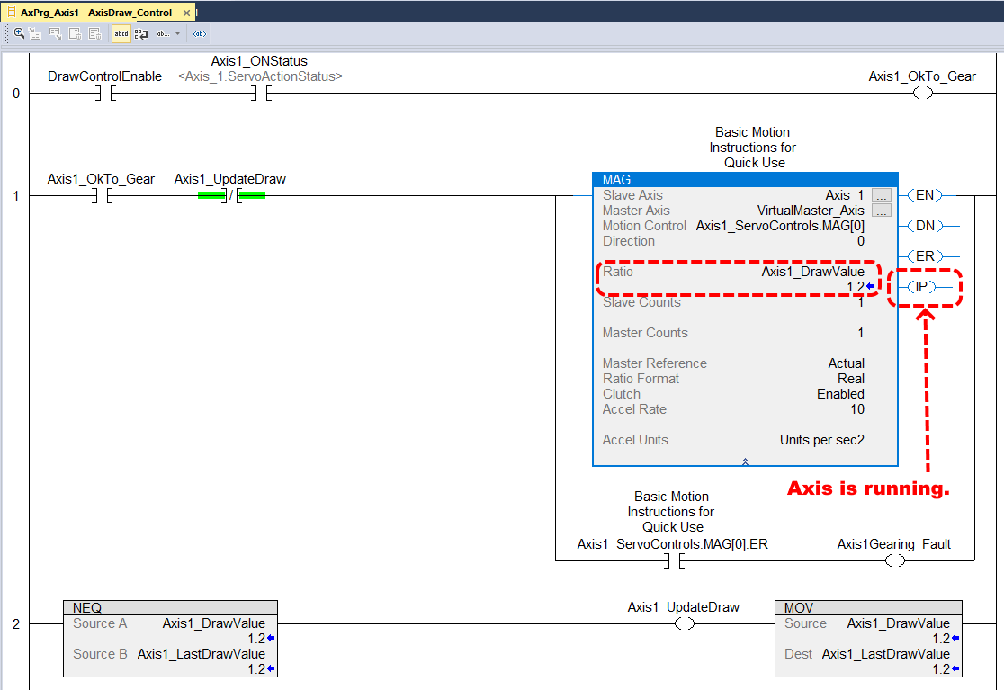

Now let’s look at the effect of the gearing. We can see the ratio is set at 1.2. We can see Axis_2 is turning at a velocity of 24, this is 1.2 times our commanded speed for the VirtualMaster of 20 (blue triangle a few screens up).

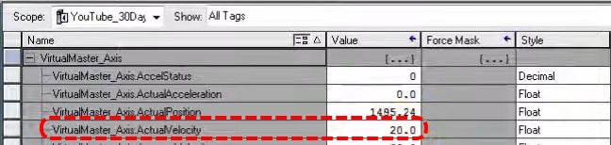

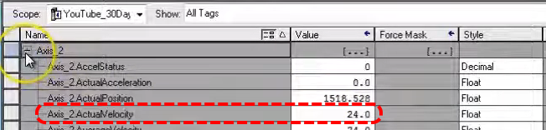

Now let’s add a Motion Axis Stop to VirtualMaster_MainProgram.

Next we will work on the state machine and transitions through the program. We will use indirect addressing. We have to create a move instruction which access an array.

Start with two move instructions, each on their own rung. On the top one for the select the tags we have already made, Machine_SSL_Array[0] which is a DINT[50] array.

Now create variable Machine_State_No as DINT with controller scope.

Now create Machine_SSL_State_No as an alias for Machine_State_No, DINT, controller scope.

Now Machine_SSL_State_No becomes the index into Machine_SSL_Array in the top move statement.

The bottom move statement populates the parameter displayed in the HMI, HMI_Machine_State_No.

The top move statement has destination Machine_SSL_Out.

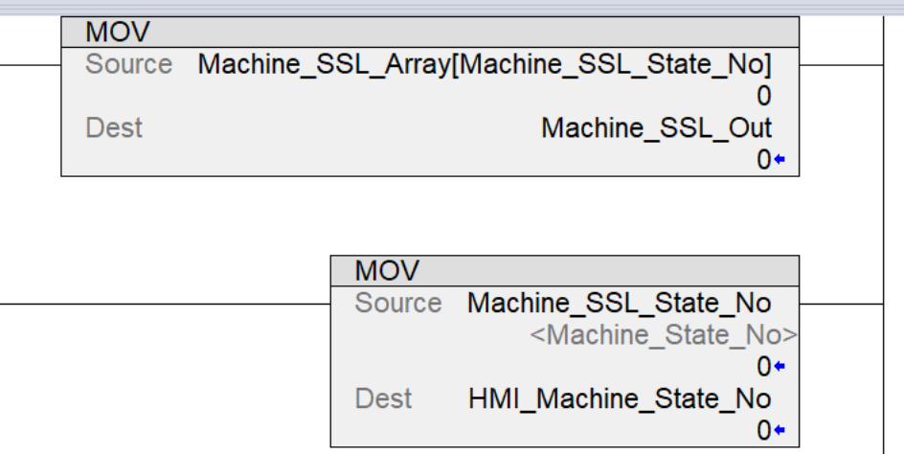

Now adding some outputs.
SSL_In1_Estop, alias for Machine_SSL_In.0, Bool, controller scope.
SSL_In_Not_Ready, alias for Machine_SSL_In.1, Bool, controller scope.
SSL_In1_SystemStop, alias for Machine_SSL_In.2, Bool, controller scope.
SSL_In1_SystemReady, alias for Machine_SSL_In.3, Bool, controller scope.
SSL_In1_SystemStart, alias for Machine_SSL_In.4, Bool, controller scope.
SSL_In1_SystemRunning, alias for Machine_SSL_In.5, Bool, controller scope.

Now we’ll add some code to shut the machine down if the axis goes into fault. We’ll also add code to shut down if the gearing faults.

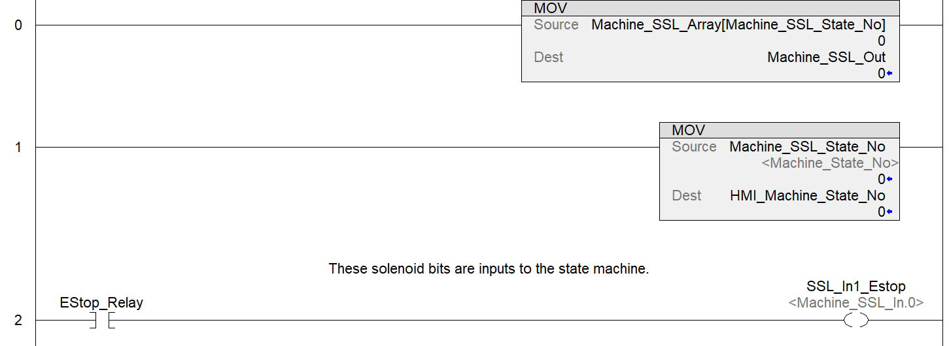

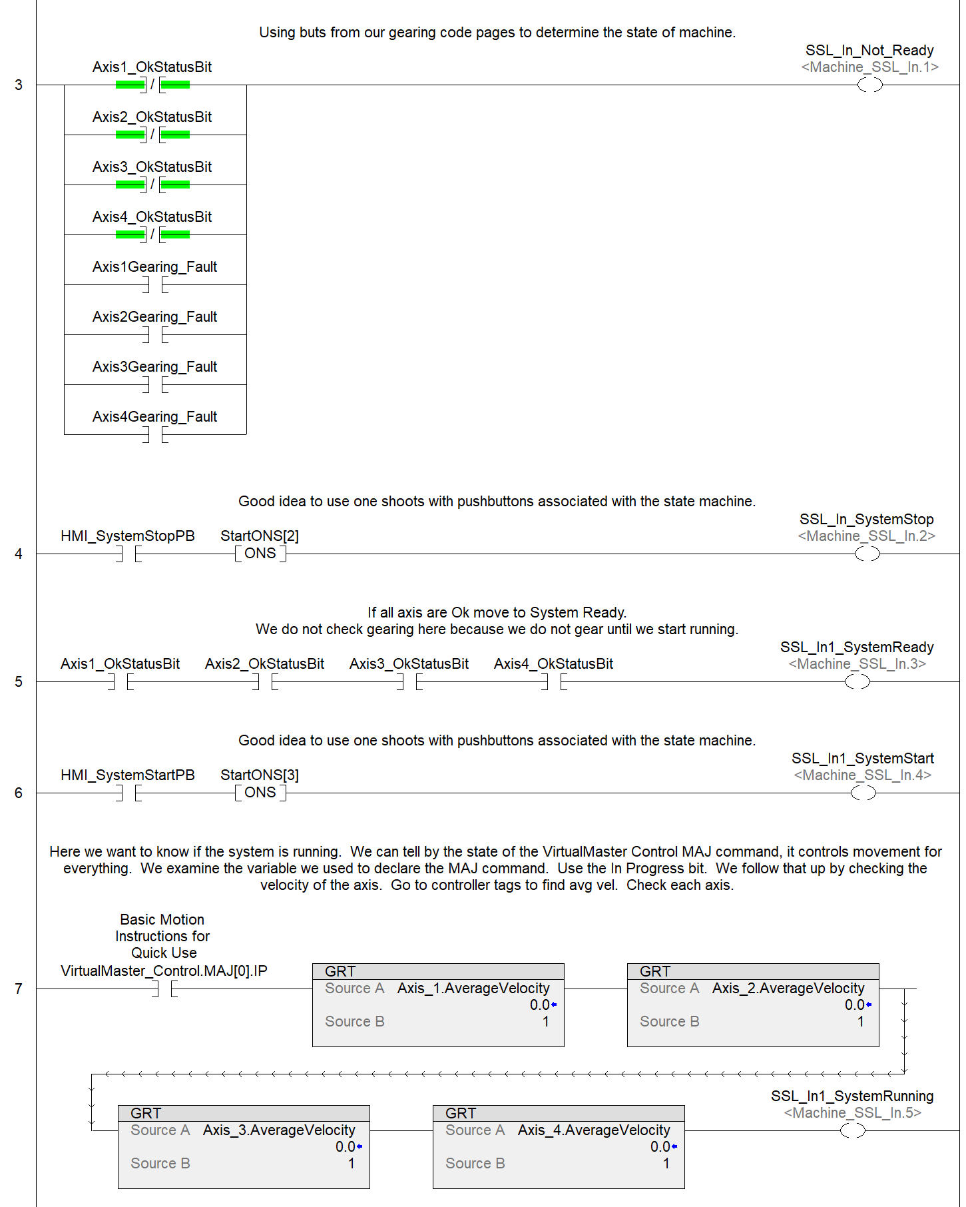

Now we will code Machine_SSL in structured text (state 2 currently not used).
“In1” seen in this code refers to inputs to the state machine.
//state control
//===============================
//0: E-Stop / Safe Device State
//1: Stopped & Not Ready
//2: Not Used
//3: Stopped & Ready
//4: System Start
//5: Wait on Stop

Case Machine_State_No of
/************************************************************************************/
/* Machine State 0 - Emergency Stop */
/************************************************************************************/
0: If NOT SSL_In1_Estop AND SSL_In_Not_Ready then Machine_State_No := 1;
elsif
NOT SSL_In1_Estop AND SSL_In1_SystemReady then Machine_State_No := 3;
end_if

/************************************************************************************/
/* Machine State 1 - Stopped & Not Ready */
/************************************************************************************/
1: If SSL_In1_Estop then
Machine_State_No := 0;
elsif
NOT SSL_In1_SystemStop AND SSL_In1_SystemReady then
Machine_State_No := 3;
end_if

/************************************************************************************/
/* Machine State 3 - Stopped & Ready */
/************************************************************************************/
3: If NOT SSL_In1_Estop then Machine_State_No := 0;
elsif SSL_In1_SystemStop OR SSL_In_Not_Ready then Machine_State_No := 1;
elsif SSL_In1_SystemStart AND SSL_In1_SystemReady then Machine_State_No := 4;
end_if

/************************************************************************************/
/* Machine State 4 - System Start */
/************************************************************************************/
4: If NOT SSL_In1_Estop then Machine_State_No := 0;
elsif SSL_In1_SystemStop OR SSL_In_Not_Ready then Machine_State_No := 1;
elsif SSL_In1_SystemRunning then Machine_State_No := 5;
end_if

/************************************************************************************/
/* Machine State 5 - Wait on Stop */
/************************************************************************************/
5: If SSL_In1_Estop then Machine_State_No := 0;
elsif SSL_In1_SystemStop OR SSL_In_Not_Ready then Machine_State_No := 1;
end_if
===========================================================================

Next we will populate the Machine_SSL_Array[Machine_SSL_State_No] array. Keep in mind that Machine_SSL_State_No is populated by the state machine ST code, as state changes we will see Machine_SSL_Array[]’s value change.

We want to demonstrate how to use this array. Machine_SSL_Array[Machine_SSL_State_No] offers a way for the state machine to take various actions based on various conditions automatically. Machine_SSL_Array[ ] is a 50 member DINT array, so each member has it’s own 32-bit DINT which we can preload with values and we can program certain actions for. For example, say we load Machine_SSL_Array[4].5 with a 1. Look what setting bit 5 to 1 does, it makes the value of Machine_SSL_Array[4] equal to 32 (2^5).

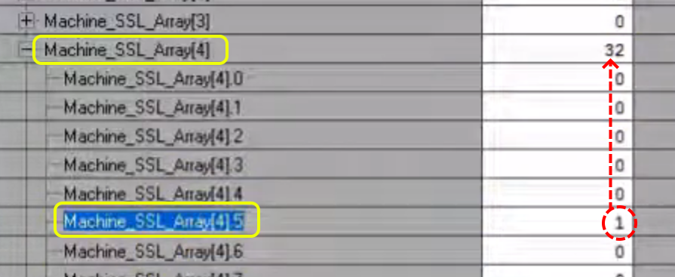

And we can see that value in the code because we are in state 4.

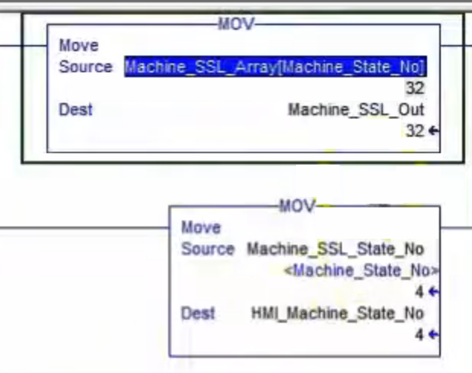
Now we can ask what output is associated with “32”? We will look at Machine_SSL_Out.

We add another value to Machine_SSL_Array[3].4 which makes Machine_SSL_Out = 16.

We can use these values in our code. In this case we will create a stop feature using nit Machine_SSL_Array[3].4 as an alias.

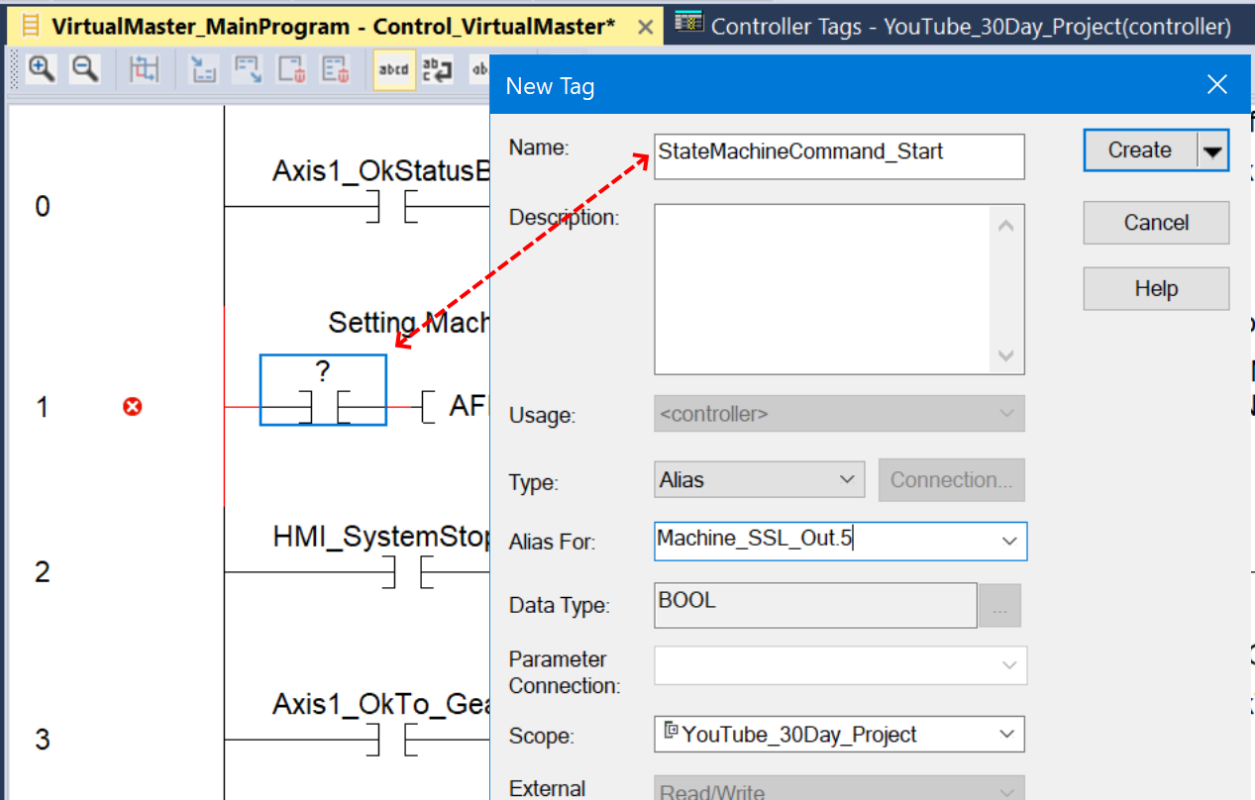
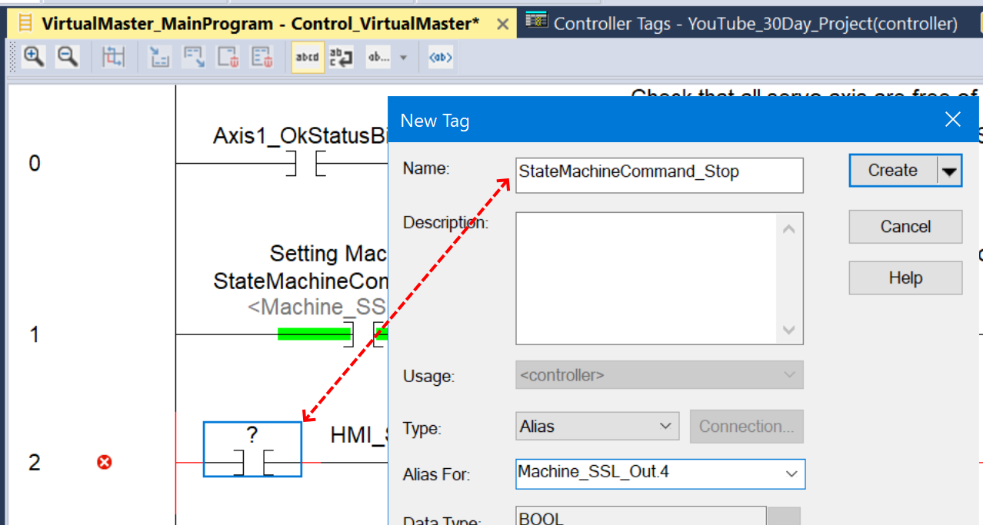

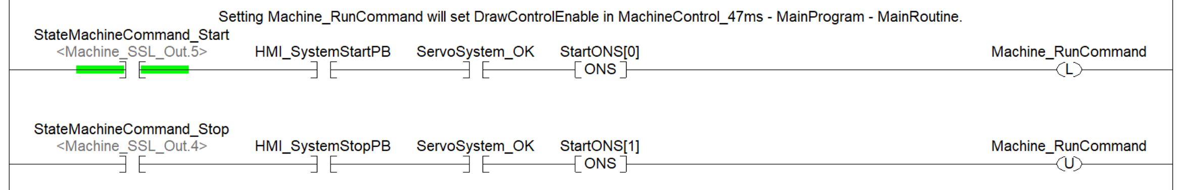
“Out” as we see here, refers to output of the state machine.

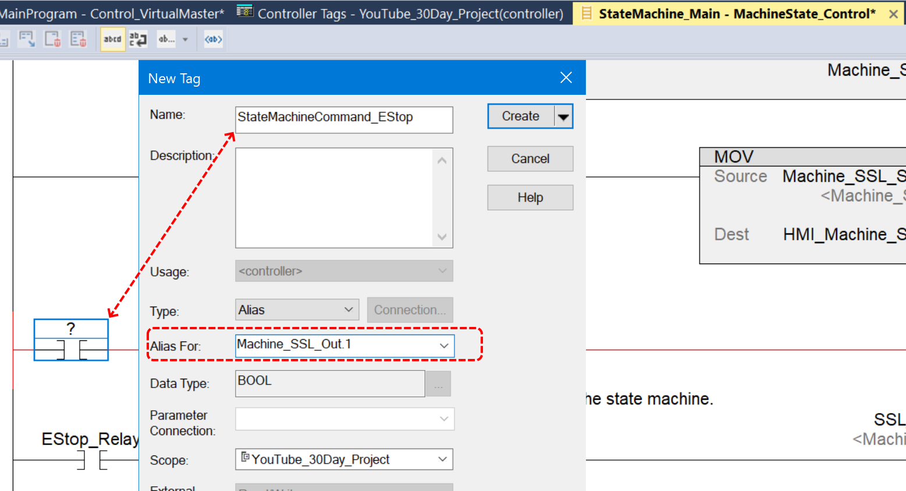

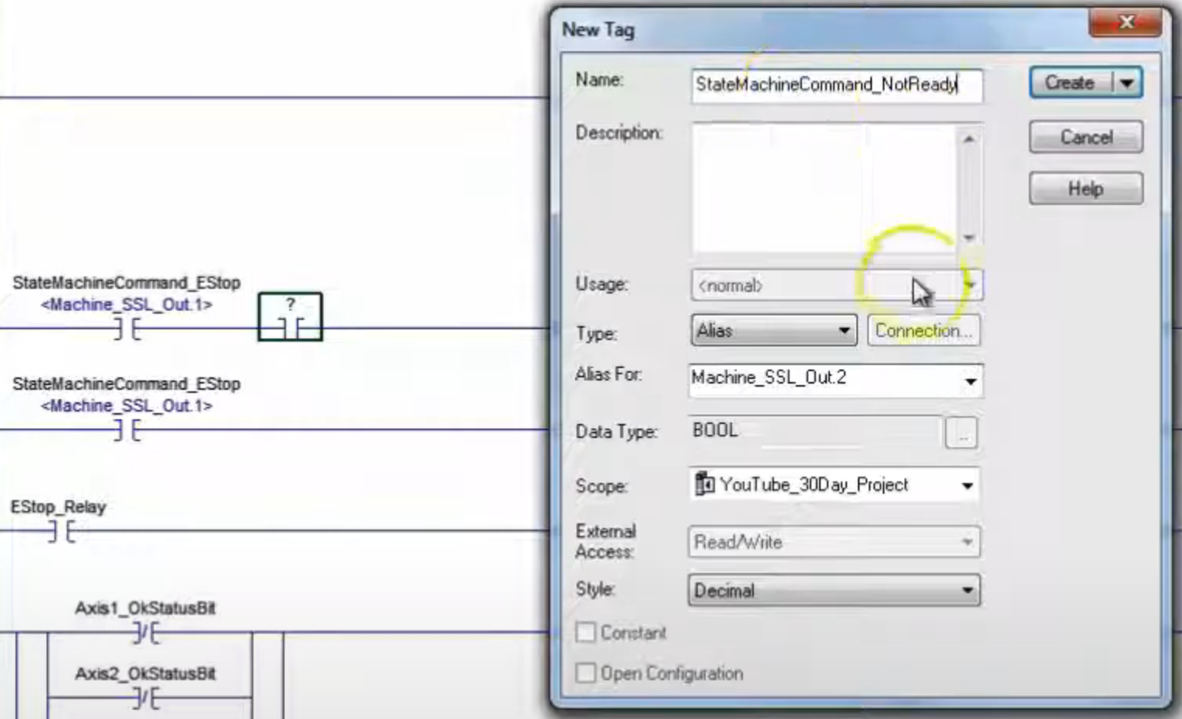

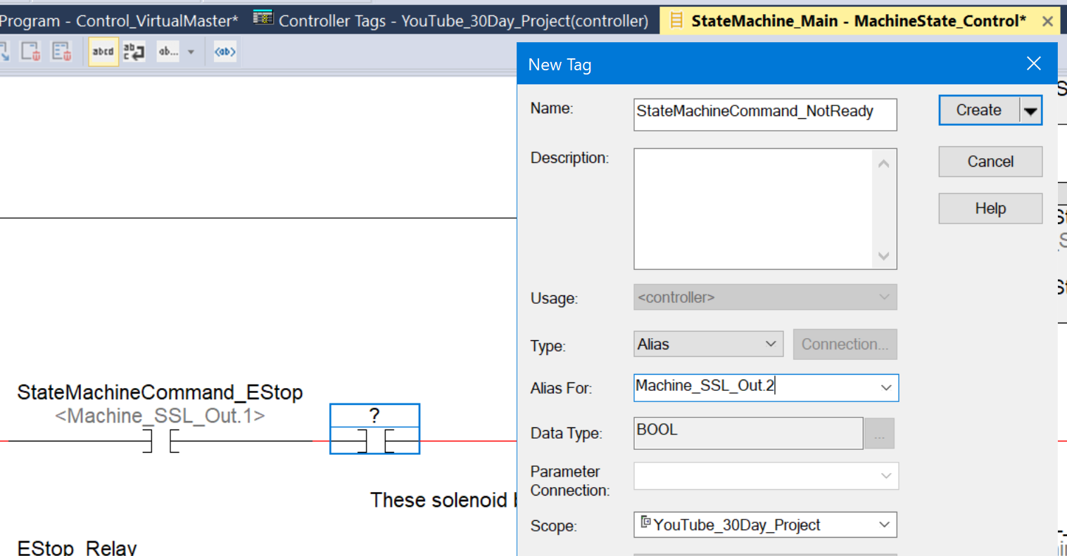

The above edit, creating StateMachineCommand_NotReady, will toggle when run.

Now we want to put in the Ready … we will make array element Machine_SSL_Array[3].3 the ready bit.
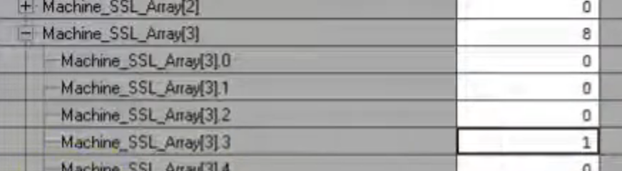

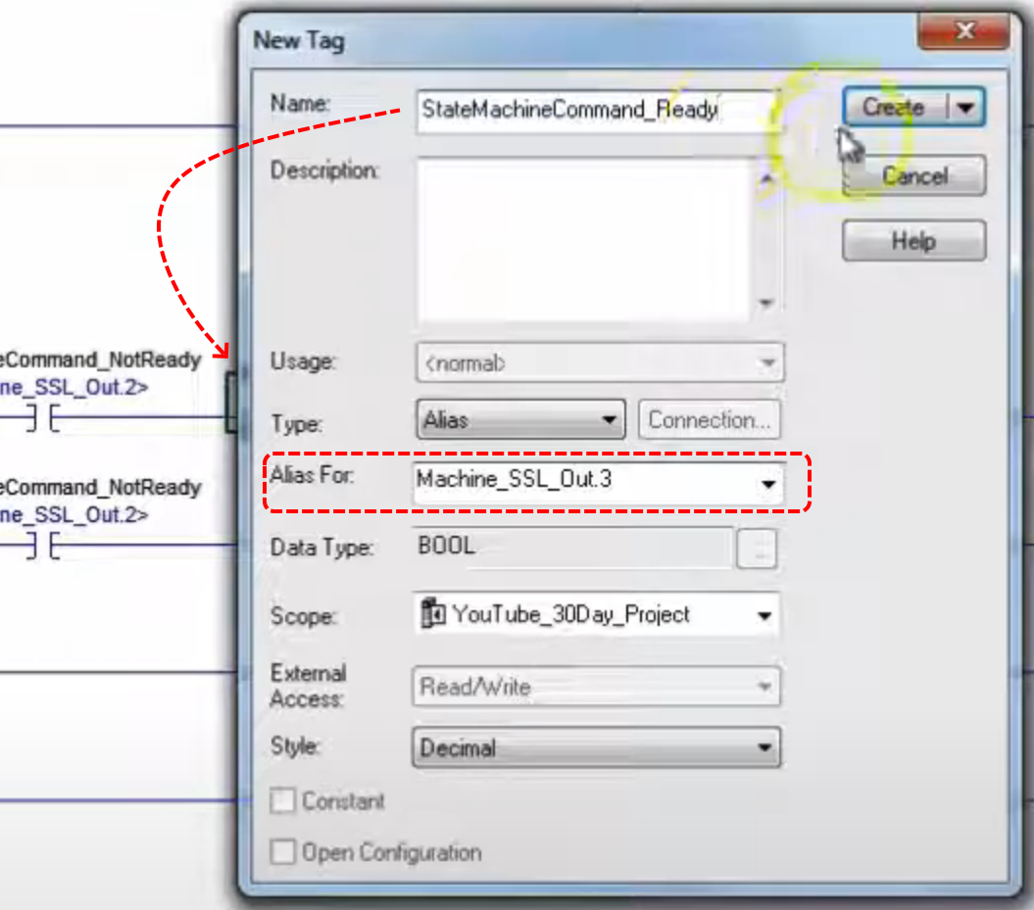

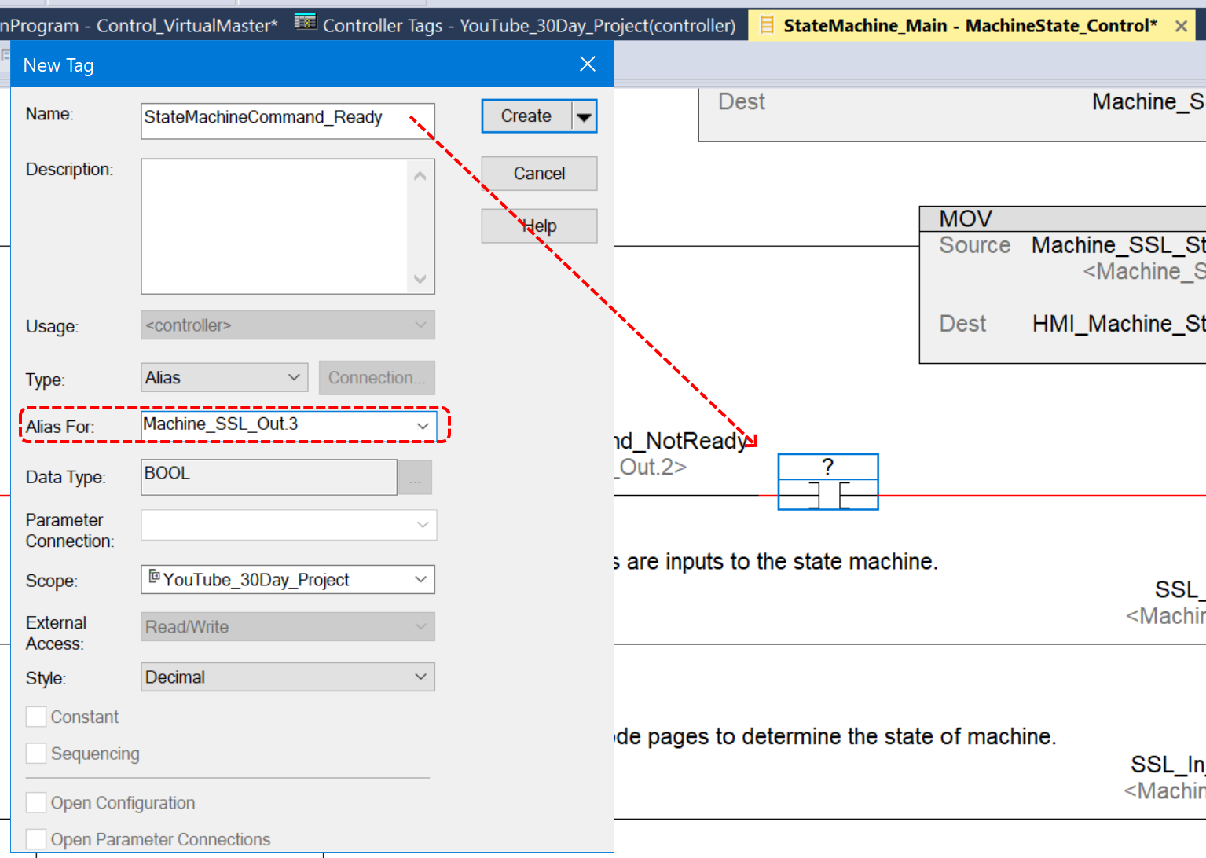

Now take the “NOP” rung to the bottom.

We need array position Machine_SSL_Array[4].5 set to one… we need a none zero value corresponding to Machine_SSL_Array[4].5.

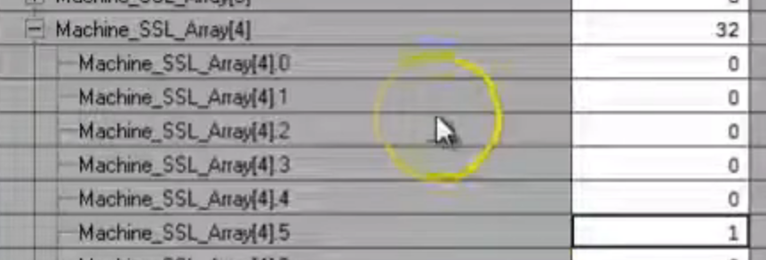

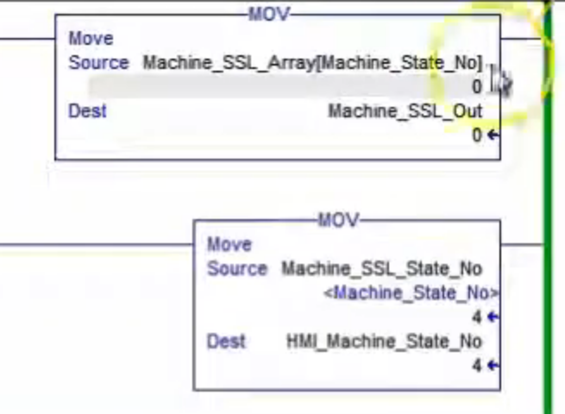

We want to use an ALMD instruction in ControlLogix. Create a new routine under MachineControl_47ms|MainProgram called SystemFault.

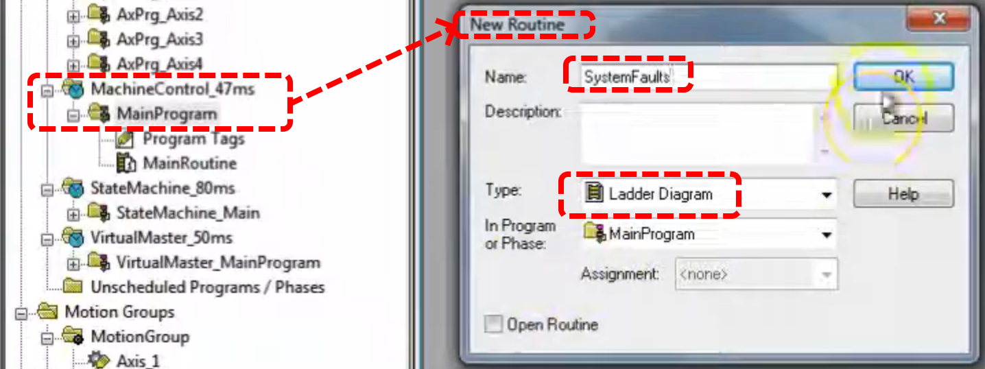

Remember to add a JSR in MainRoutine to call this function.

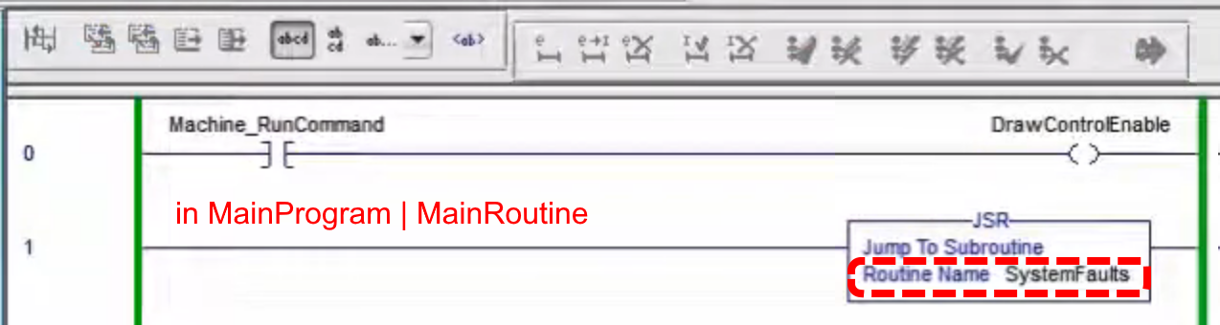

Now the idea is to make alarms for all the faults we capture. Two types of alarms, analog & digital.
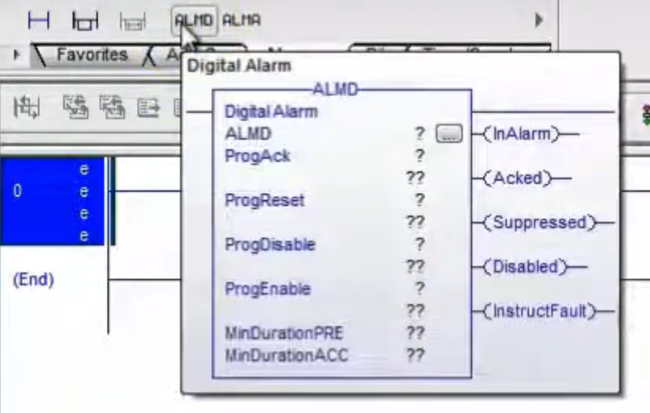
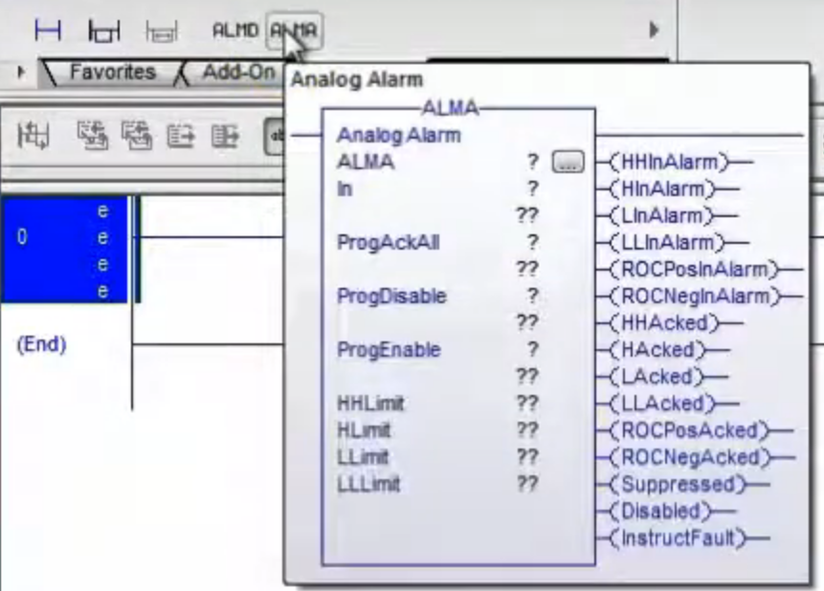
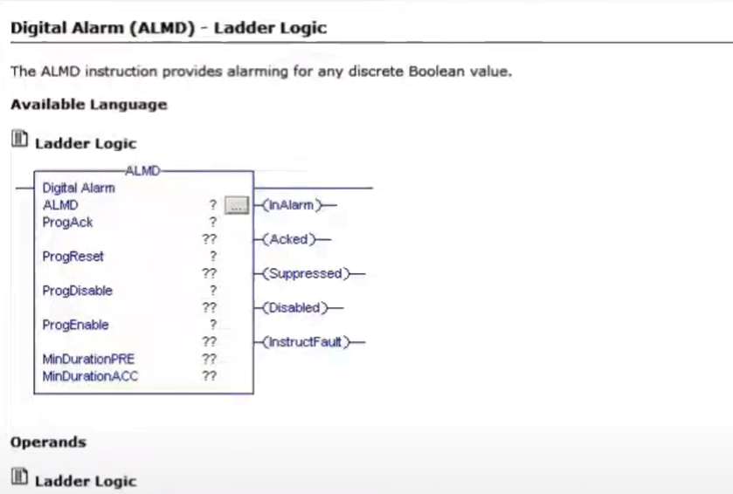
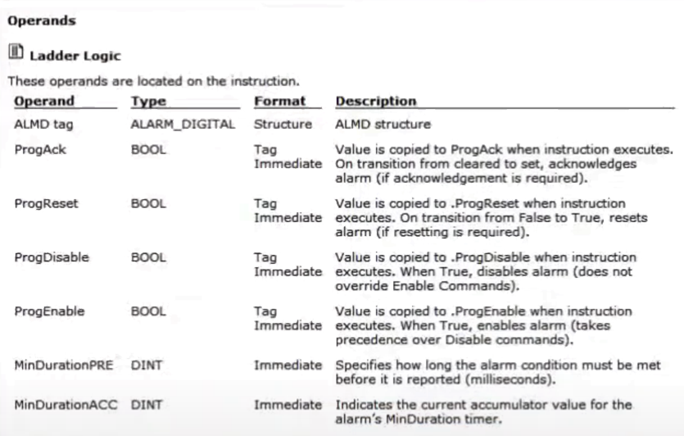
Need Alarms Enabled in RSLynx.

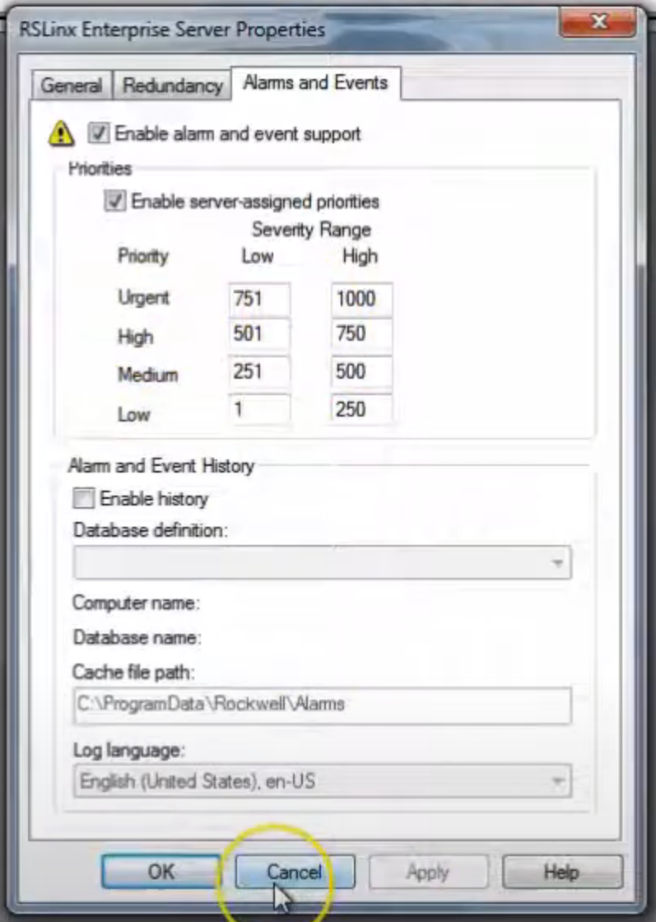

On the communications panel of FactoryTalk View you must also have alarms enabled.

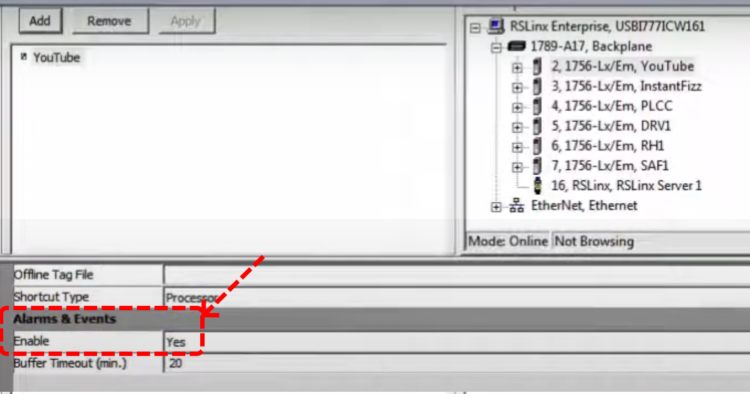

Now back in Logix Designer create a new tag for the first alarm, be sure to check “Open ALARM_DIGITAL Configuration” before clicking create. It is a controller scope tag.

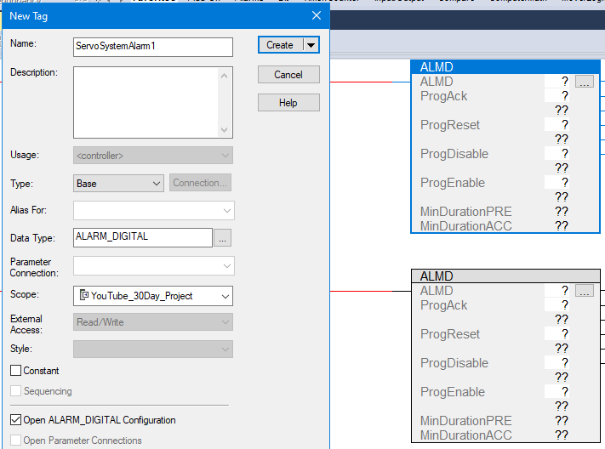
Enter the Severity, this is E-Stop so it will be 1000.

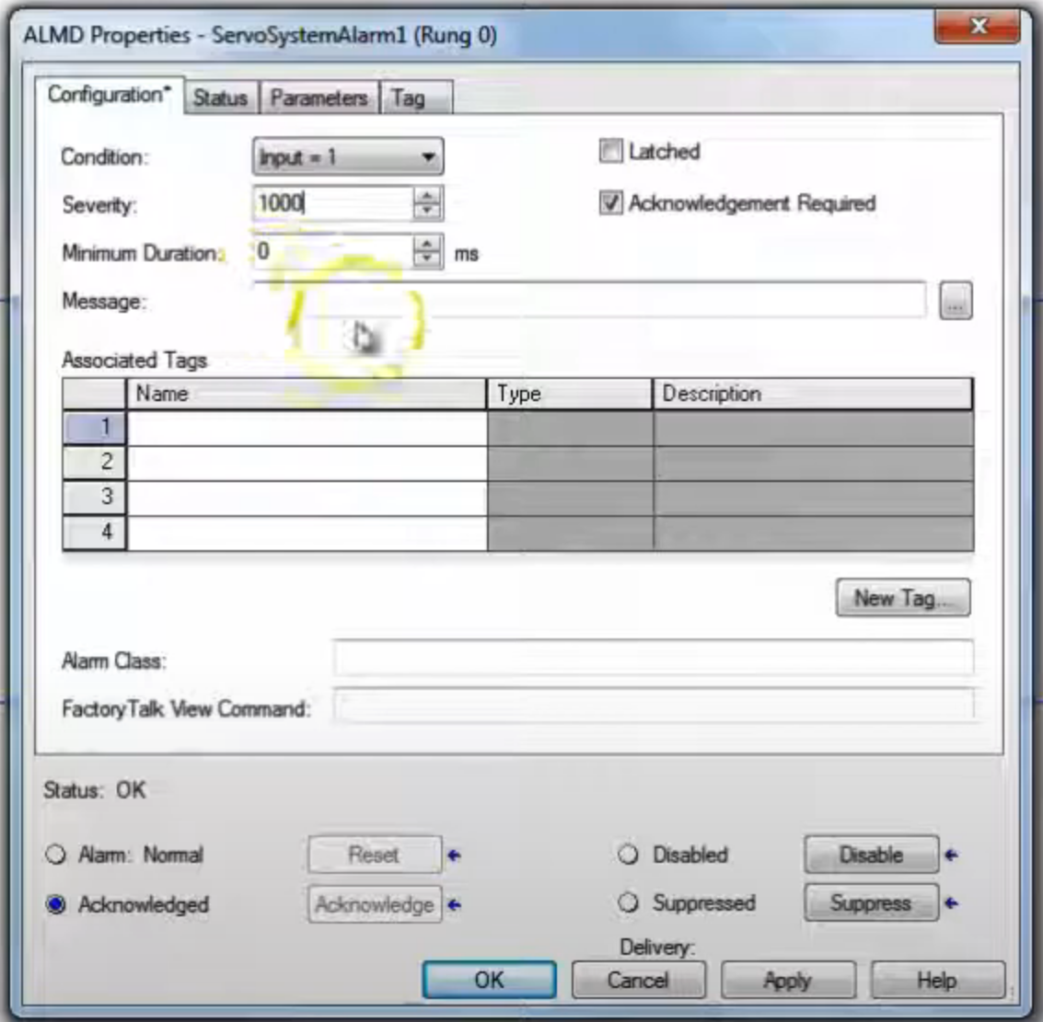

Click the Name field under Associated Tags and click New Tag, create as shown below.

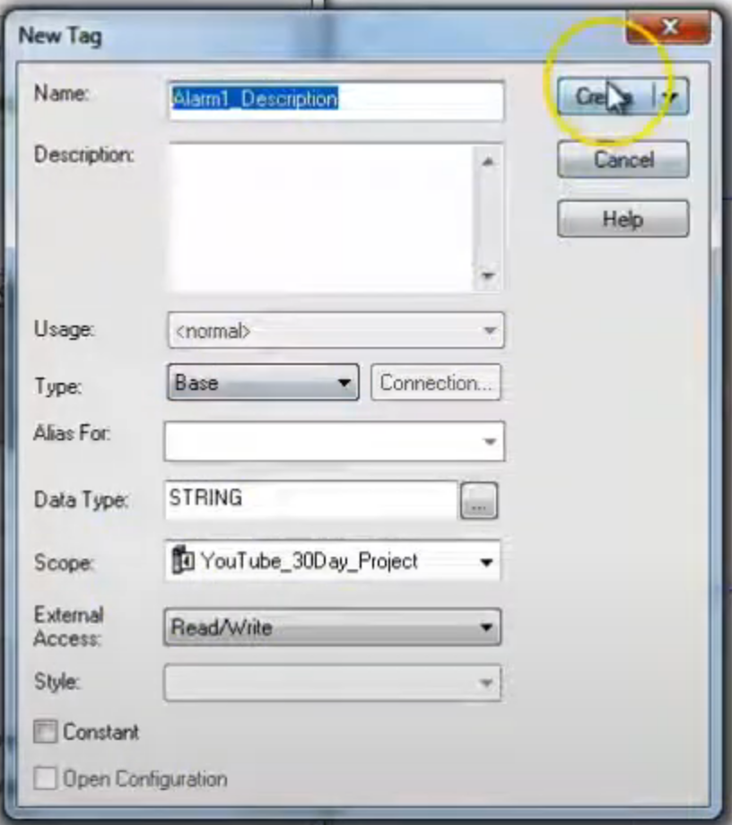
Click ellipse on Message.

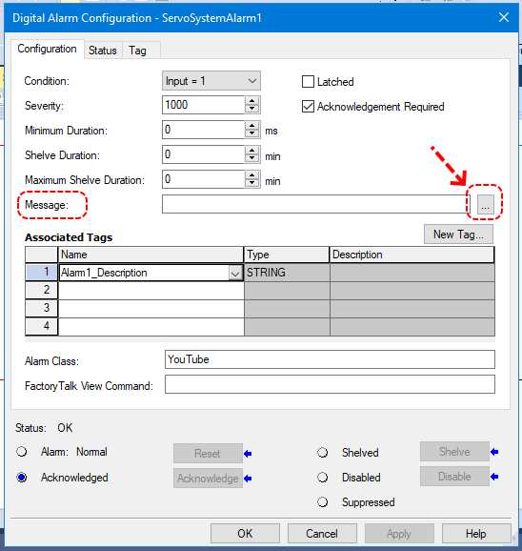

Select “Tag 1 (Alarm1_Description)” then click Add and then click OK.

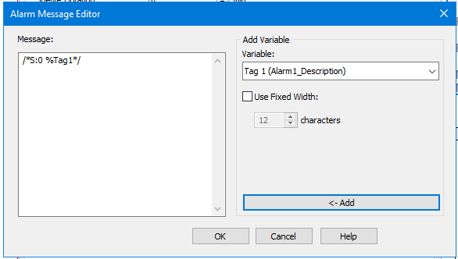

Must set Alarm Class equal to the shortcut created for comms in FT View.

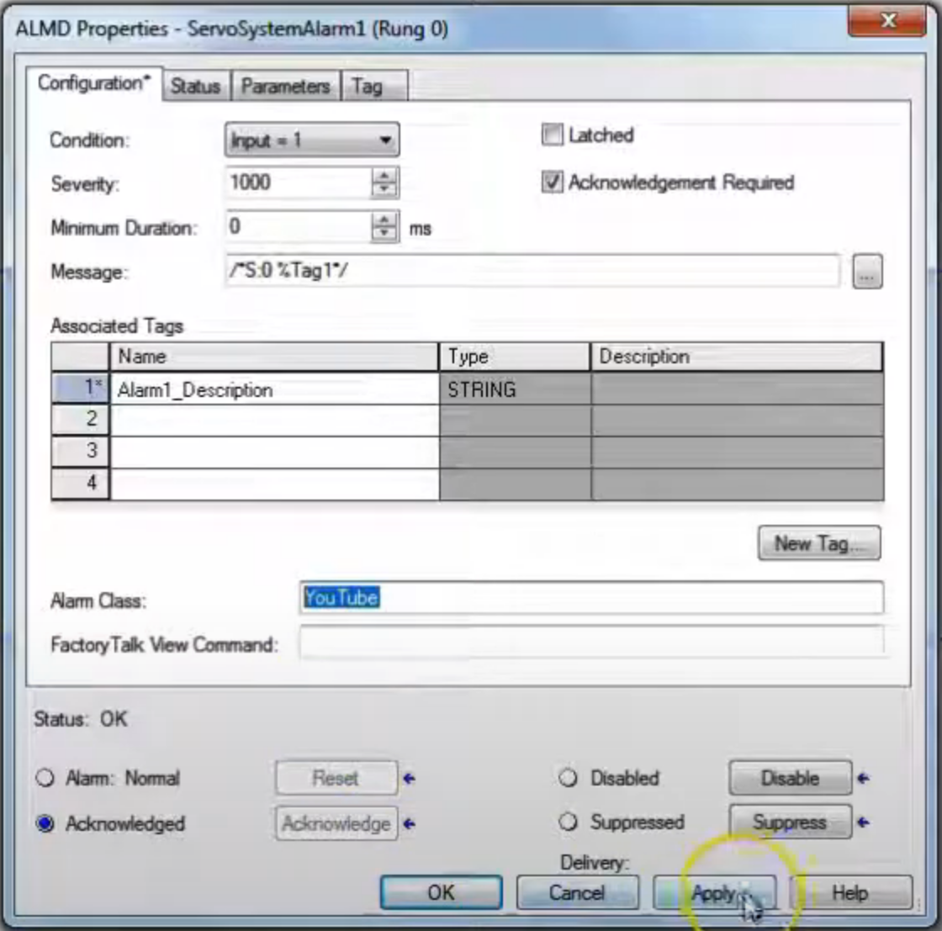

Do the same for remaining axis status bits. Use 750 severity for non E-Stop.

For now set all the ALMD fields equal to zero.

Add the contacts to each rung as shown below.
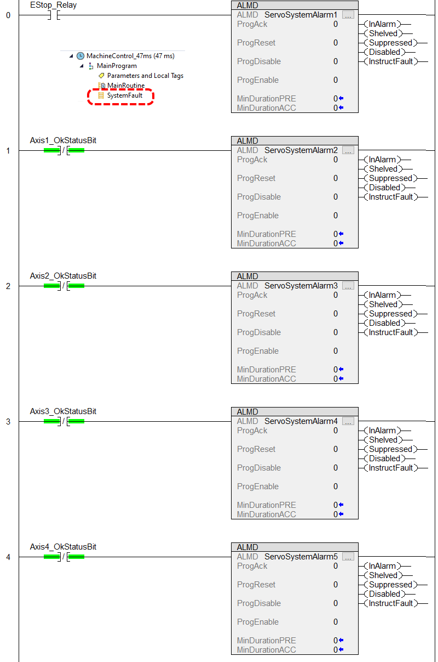
Now we will populate our alarm description tags with the data they need to describe (Value field). Look them up in controller tags and click the ellipse.

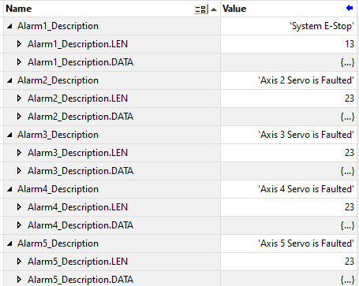

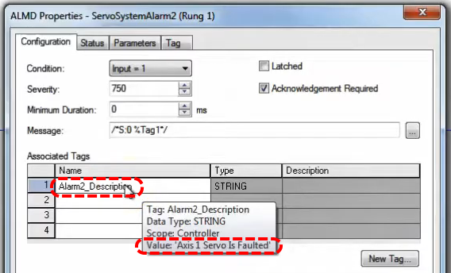

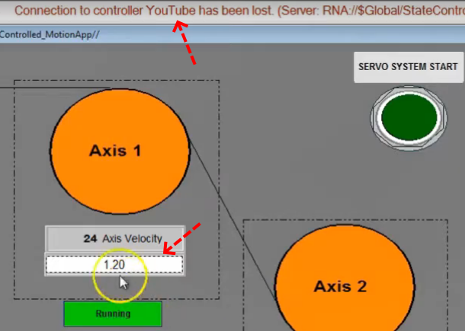

Now when we run our app we get a message up top saying the connection to the controller is broken even though we can see that we have comms. An adjustment needs to be made. We have an RSLynx problem (there exist a RW tech note on this problem). Go to control panel, click on Administrative Tools, double click on Component Services, then Services (Local), scroll down to RSLinx Enterprise, right click and Restart, do this while the system is active. Rebooting the computer will not fix this on non-server based systems. The status line should display faults now.

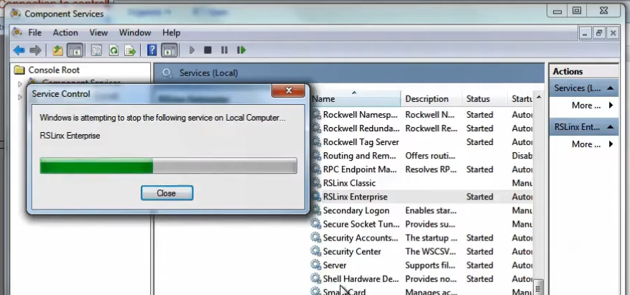

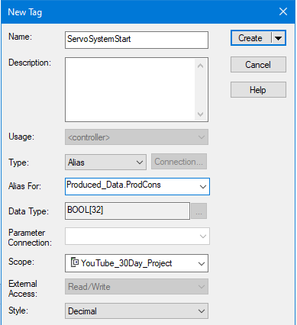
Now create a rung in PLC that will activate the remote tag (kind of assuming both machines require remote start of each other for demonstration purposes). Set up this button in MachineControl_47ms | MainProgram | MainRoutine.

Note that we select a specific instance of Produced_Data for this Bool.

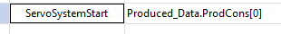

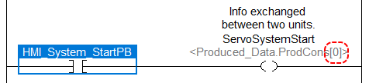

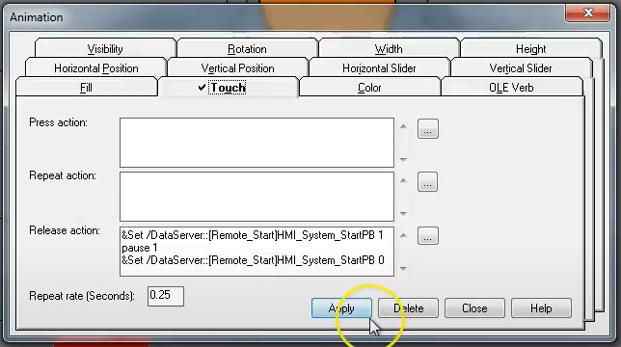

So now when we access data from the other processor via produce/consume we have to change the shortcut data path in the HMI as well.

The End

